 | John Doe  Title  Pronouns:  p: (401) 341- 0000 e: john.doe@salve.edu  100 Ochre Point Ave., Newport, RI 02840  salve.edu

Instructions
- Once you have the email signature open in Word, copy all elements of the email signature

- Open Microsoft Outlook desktop app
- Click “New Email” or “New Message”
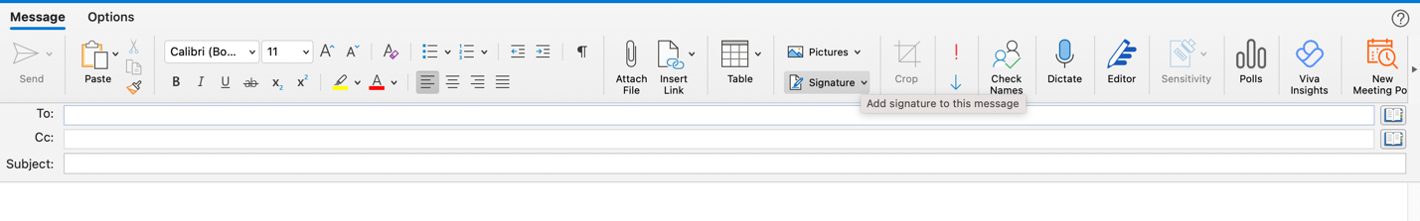
- Click “Signature” > “Edit Signatures” / “Manage Signatures”
- Click “Edit”
- Paste email signature from Word
- Edit signature with your own name, title, phone number, and email address
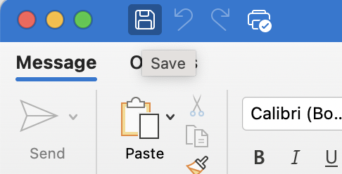
- Click the Save icon
- Go to “New messages:” set it as Standard and “Replies/forwards:” set it as Standard
- Exit window and the new signature should be set
- If you use a web browser to view and send emails, continue to the next steps
- Send an email to yourself from the Microsoft Outlook desktop app
- Open that email in a web browser at outlook.office.com
- Copy your email signature from the email you just sent yourself
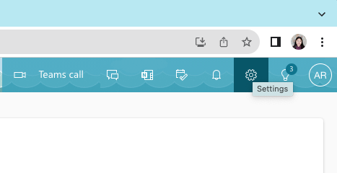
- Go to Settings
- Click “Compose and reply”
- Paste signature into the email signature box
- Save email signature

